Can You Catch the Water?

Summary
Students construct three-dimensional models of water catchment basins using everyday objects to form hills, mountains, valleys and water sources. They experiment to see where rain travels and collects, and survey water pathways to see how they can be altered by natural and human activities. Students discuss how engineers design structures that impact water collection, as well as systems that clean and distribute water.This engineering curriculum aligns to Next Generation Science Standards (NGSS).
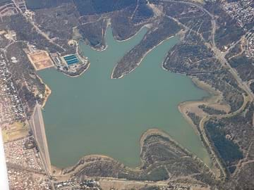A reservoir is a type of water basin that holds water in one place
copyright

Engineering Connection
Catchment basins and watersheds are important to most living things, since water flow, direction and location are vital to water availability for everyday life. Environmental, chemical and civil engineers, along with geologists and hydrologists are all interested in catchment basins, how they change, and how water flows through them. Recently, in the Earth's geologic timeline, we are seeing catchment basins changing in response to human water diversion and water collection activities. How human-made technologies affect our water sources, water quality and watersheds is of great importance to protect the people, industries and wildlife that depend upon a working system of clean water for survival.

Learning Objectives
After this activity, students should be able to:
- Define and describe a catchment basin.
- Define and describe a watershed.
- Relate their model basin to real-world water flow patterns.
- Explain engineers' involvement with watersheds and catchment basins.
- Describe how some of the Earth's systems interact (hydrosphere, atmosphere and geosphere).

Educational Standards

NGSS: Next Generation Science Standards - Science

International Technology and Engineering Educators Association - Technology

State Standards
Suggest an alignment not listed above

Materials List
For the Introduction/Motivation activity, each student needs:
- 1 blank note card
- pencil or pen
For the activity, each group needs the following (or similar) items:
- a variety of objects to build land-forms, such as small cups, jars, bowls, plates, rocks, blocks, crunched paper towels, etc.
- sheet of light-weight plastic, ~1 x 1 meter (a slit-open trash bag works well)
- (optional) spray bottle filled with water, to deliver "rain" to the catchment basin
- (optional) masking tape, to hold items in place, to secure the plastic sheet
- (optional) newspaper
- sponge
- a few drops of food coloring
- Catching Water Worksheet, one per student

Worksheets and Attachments
Catching Water Worksheet (docx)
Catching Water Worksheet (pdf)

